Format to report your ADVANCED JAVA PROGRAMMING PROJECTS

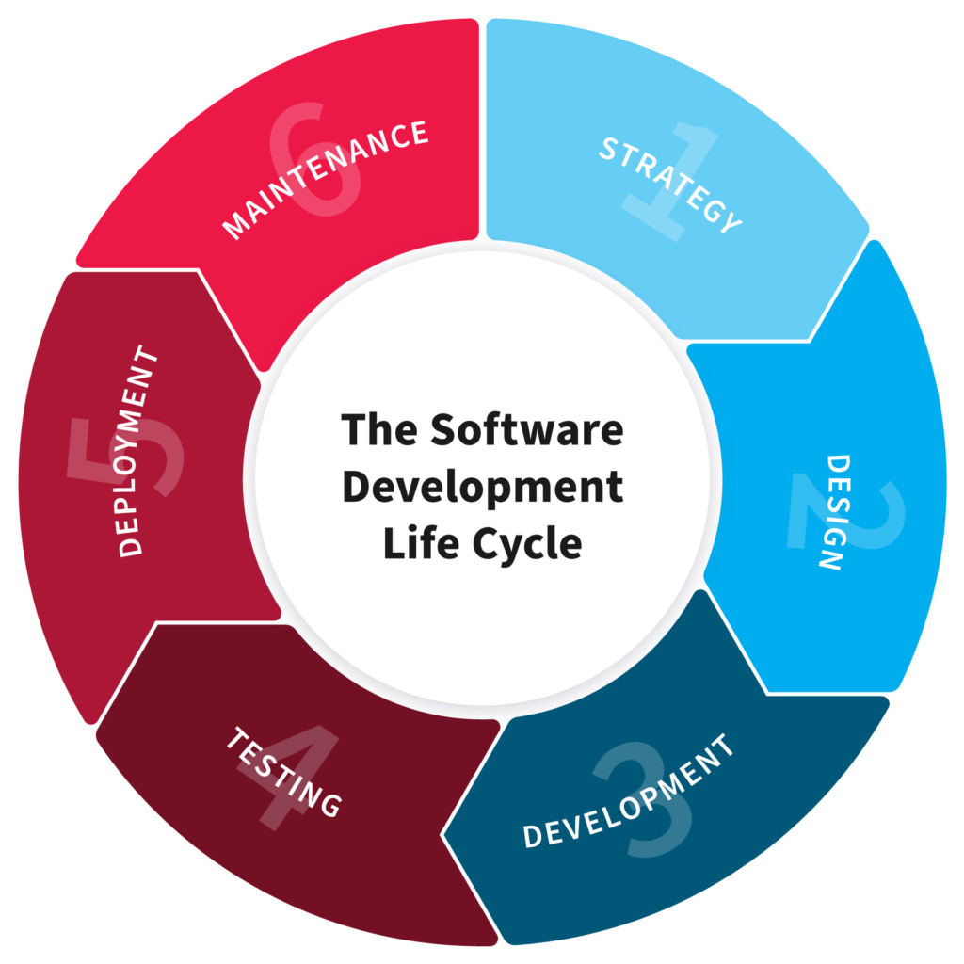

NB: EVERY STUDENTS HAS TO PRODUCE THIS DOC

NAME: SIBOMANA Eric
REG NO: 221005748
CLASS NO:

PROJECT NAME: Airline Ticket Management System

1.PLANNING

Airline ticket management system is a kind of user assistance where reservation company can record information for customers information and flight. This is easy which saves a lot of time.

The main objective of this project is to store information of customer and flight in properly way and securable.

The manual system of Airline ticket management system company using notebook and papers to record information, this manual system is slow, time consuming and it’s very difficult for record each person to book through office agents.
This require a lot of time and wastage of money as it requires quite a lot of manpower.

- Design

Our design phase shows user how our system function are flows in order to perform task in such way that the user can make it easily, and also shows most important functionality requirement user can perform in the system.

Function requirement of our project
- Login page: user must to login using user name and password, system make identification and verification whether it’s true you continuous to the home page or it’s false you get message for incorrect of user-name and password.
- Home page: this page link various pages in order to perform task such as passenger, flight, booking and cancellation.
- Passenger Page: it’s enable to record of information to customer where you granted to add new record, update, view, and delete.
- Flight page: help to record information about on flight which are a available and seat number.
- Ticket page: it’s allow us to book ticket for customer who make ticket reservation.
- Cancellation: this page it’s very important because it provide option of cancelling ticket when there is any issue to the customer.

Non-function requirement of our project
- Security: project must be securable for login system to identify the access of user and granting role to them.
- Flexible: our project is user friendly beacouse process it’s well clear understandable
- Portability and compatibility: it can be compatible with different hardware, operating systems, and browsers, along with their versions does the software run on.
- Reliability, maintainability, availability: Our system is reliable and maintainability because it is able to protect the client's data, even when there is a problem and it is easy to be maintained and it’s can be accessible any time.
- Localization: the system compatible with local specifics.
- Usability: easy is it for a customer to use the system.

3. Development

To building our project we try to integrate front end and back end technology
In creating the front end, we used the Net-beans platform, which help us to combine different elements in our design and includes pages that help the user in using the application.

Front end is a part that users actually see and interact with. We developed front-end by using NetBeans platform that allow users to access and interact with our system.

Back end side is the part of our project that deals with the server-side of a system. This includes creating and managing the server-side logic, connecting the project to a database, handling user authentication and authorization, and processing and responding to user requests. It often involves the use of programming languages such as Java.

For building front end and back end we used the following tools:

Libraries: Mysql-connector, jCalender, r2mxl.jar
Platform: NetBeans application
Storage and database: MySQL
Server: Xampp
Main tools: Computer and network.

4.Testing

Testing it helps to ensure the quality and reliability of our project. and also testing phases of our project help us to identify all the bugs and errors in the software before the deployment phase begins.

This phase helps to insure that the system meets the objective of the project.
It is also necessary to test whether project works properly on the planned delivery platform like computer and meets the needs of the clients.

There are some stages we used in testing our project.

Unit testing
The goal of unit testing is to validate individual components.
Integration testing
The goal of integration testing is to validate the integration interfaces or points between individual functions or components.
System testing
The goal of system testing is to determine that services are able to produce the required functionality when they are integrated to create a project process within a system.
System integration testing
The goal of system integration testing (SIT) is to verify services functionality when integrated to create an end-to-end project process that spans across multiple systems.
Performance testing
The goal of performance testing is to determine the system performance under a defined workload using different types of performance testing such as load, stress, and soak testing.

5.Deployment

The deployment phase is the final step in the software development life cycle and delivers the final product to the customer in a live production environment.

The Deployment Phase includes the work necessary to deploy the final solution into the target production environments.
Plus, creating guides for installation, system operations, system administration, and end-user functionality.

This phase it's involve in installation of system in various platform in order to know how it works on, and training end user to use your project.
For installing our project in devices platform there are some tools is required to install in computer such as:
- Java development kit(JDK)
- NetBeans platform
- MySQL-connector libraries,
- jCalendar libraries
- r2mxl libraries
- Xampp server
- MySQL databases

Tasks and Activities of Deployment Phase

Execute the Training Plan
It ensures that you are executing the desired training plan.

Perform the Data Entry or Conversion
It makes sure that you are performing the data entry or the necessary conversion if required.

Install the System
It ensures that the system is fully operational and installs the system in a production house.

Post-Deployment Review
It documents the deployment experiences, recommends the system enhancements, and guides future projects.

Revise Previous Documentations
All the relevant documents must be reviewed and updated, considering all the changes introduced by the project. For example, report documentation must always reflect the current state of the report.

Conclusion

All these steps above helped us to think about our project, we think about the necessary information and tools to help us in building the project,
It helps us to build a better environment for us.
we do its testing and look at its performance work.
deployment that helps us to deliver the final project and also help to educate the users to know how to use it,
and creating project documentation that explains how the project is built and used.

